SIMATS ENGINEERING

COURSE NAME: Artificial Intelligence
COURSE CODE: CSA1735
NAME: Melosa Larissa Deniz
Reg no: 192417005

Experiment 11: Map Coloring Using CSP
Aim: To write a Python program to implement Map Coloring using the Constraint Satisfaction Problem (CSP).
Algorithm:
- Define the regions and their neighboring regions.
- Assign a list of available colors.
- Select an uncolored region.
- Assign a color that differs from its neighbors.
- If no color is valid, backtrack and try another color.
- Display the final color assignment.
Program:
colors = ['Red', 'Green', 'Blue']

graph = {
'A': ['B', 'C'],
'B': ['A', 'C', 'D'],
'C': ['A', 'B', 'D'],
'D': ['B', 'C']
}

assignment = {}

def is_valid(region, color):
for neighbor in graph[region]:
if assignment.get(neighbor) == color:
return False
return True

def solve(regions):
if not regions:
return True

region = regions[0]

for color in colors:
if is_valid(region, color):
assignment[region] = color

if solve(regions[1:]):
return True

del assignment[region]

return False

if solve(list(graph.keys())):
print("Map Coloring Solution:")
for region, color in assignment.items():
print(region, ":", color)
else:
print("No solution exists")
Output:
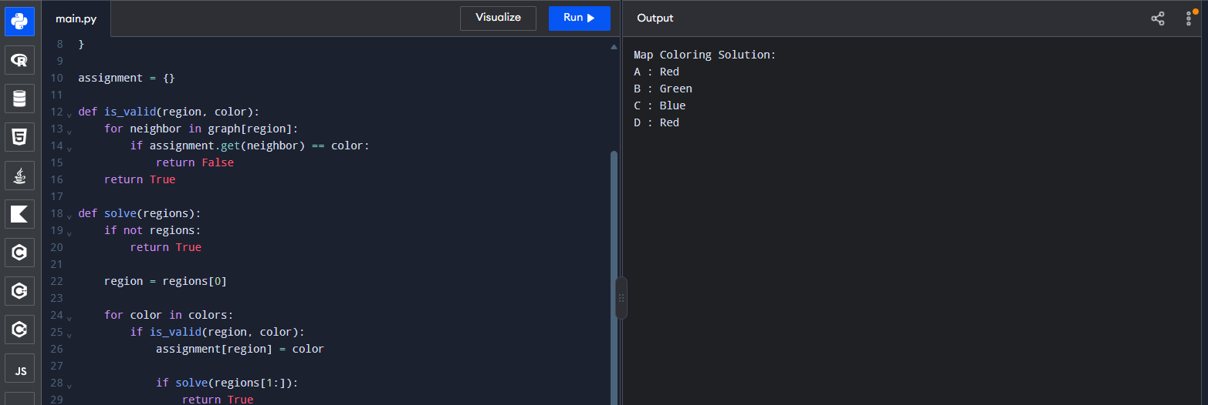Result: Thus, the Map Coloring problem was solved successfully using CSP and backtracking.

Experiment 12: Tic-Tac-Toe Game
Aim: To write a Python program to implement the Tic-Tac-Toe game.
Algorithm:
- Create a 3 × 3 board.
- Display the board.
- Allow two players to enter their moves.
- Check for a winning combination after every move.
- If all cells are filled without a winner, declare a draw.
- Stop the game when a player wins or a draw occurs.
Program:
board = [' '] * 9

def display():
print(board[0:3])
print(board[3:6])
print(board[6:9])

def winner():
lines = [
(0, 1, 2), (3, 4, 5), (6, 7, 8),
(0, 3, 6), (1, 4, 7), (2, 5, 8),
(0, 4, 8), (2, 4, 6)
]

for a, b, c in lines:
if board[a] == board[b] == board[c] != ' ':
return board[a]
return None

player = 'X'

while ' ' in board:
display()
move = int(input(f"Player {player}, enter position (1-9): ")) - 1

if move < 0 or move > 8 or board[move] != ' ':
print("Invalid move!")
continue

board[move] = player

if winner():
display()
print("Player", player, "wins!")
break

player = 'O' if player == 'X' else 'X'
else:
display()
print("Game Draw!")

Sample Output:
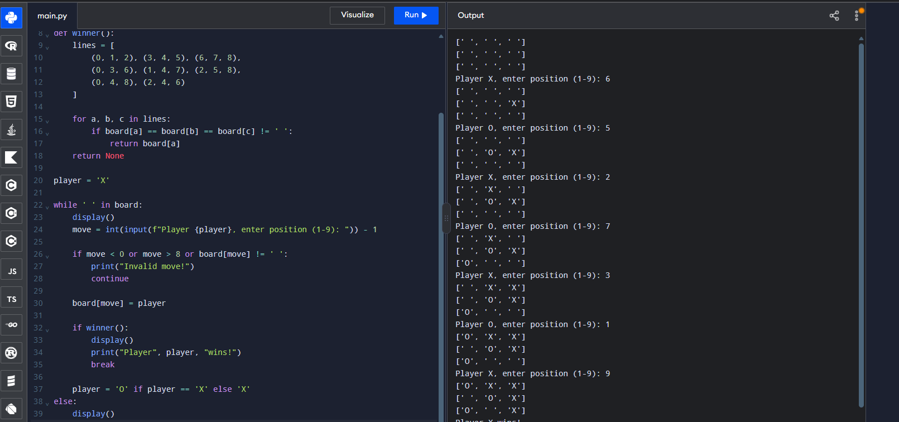Result: Thus, the Tic-Tac-Toe game was implemented successfully using Python.

Experiment 13: Minimax Algorithm for Gaming
Aim: To write a Python program to implement the Minimax algorithm for gaming.
Algorithm:
- Initialize the Tic-Tac-Toe board.
- Generate all possible moves.
- Evaluate each move using the Minimax algorithm.
- Select the move with the highest score for the computer.
- Repeat until a player wins or the game ends in a draw.
Program:
def minimax(board, is_max):
lines = [
(0, 1, 2), (3, 4, 5), (6, 7, 8),
(0, 3, 6), (1, 4, 7), (2, 5, 8),
(0, 4, 8), (2, 4, 6)
]

for a, b, c in lines:
if board[a] == board[b] == board[c] != ' ':
return 1 if board[a] == 'O' else -1

if ' ' not in board:
return 0

scores = []

for i in range(9):
if board[i] == ' ':
board[i] = 'O' if is_max else 'X'
scores.append(minimax(board, not is_max))
board[i] = ' '

return max(scores) if is_max else min(scores)

board = [' '] * 9

while True:
print(board[0:3], board[3:6], board[6:9], sep='\n')

move = int(input("Enter your move (1-9): ")) - 1

if move not in range(9) or board[move] != ' ':
print("Invalid move!")
continue

board[move] = 'X'

if minimax(board, True) == -1:
print("You win!")
break

if ' ' not in board:
print("Draw!")
break

best_score = -float('inf')
best_move = None

for i in range(9):
if board[i] == ' ':
board[i] = 'O'
score = minimax(board, False)
board[i] = ' '

if score > best_score:
best_score = score
best_move = i

board[best_move] = 'O'

if minimax(board, False) == 1:
print(board[0:3], board[3:6], board[6:9], sep='\n')
print("Computer wins!")
break

if ' ' not in board:
print("Draw!")
break

Sample Output:
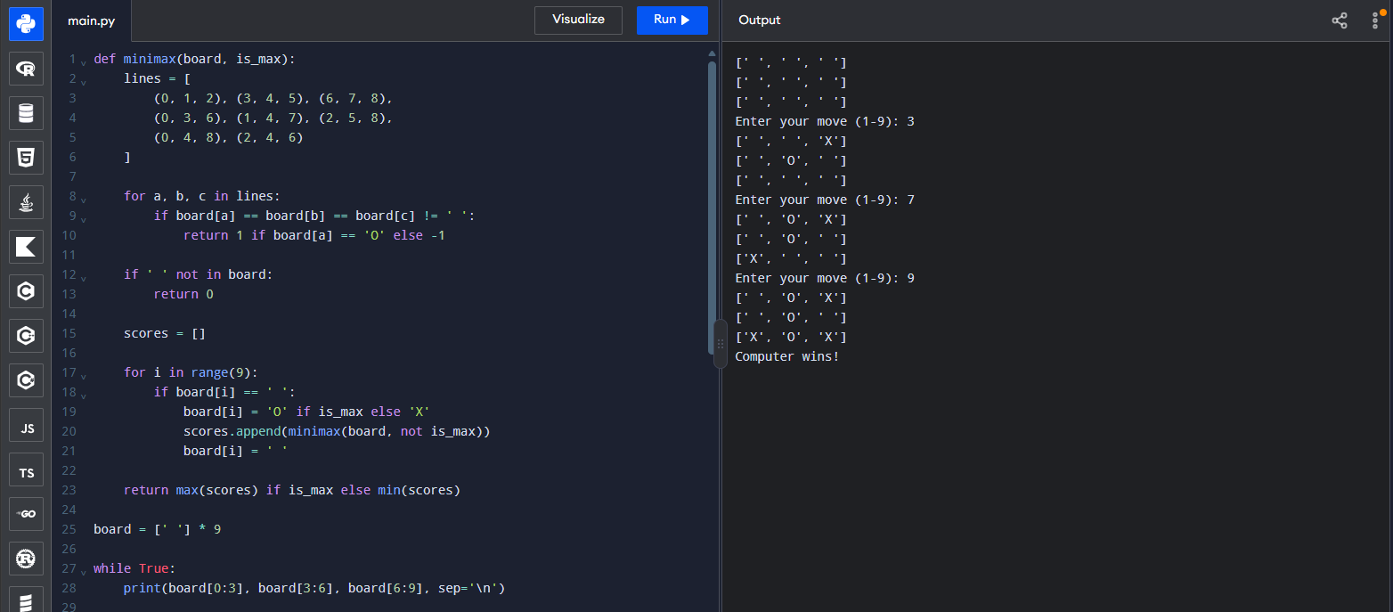
Result: Thus, the Minimax algorithm was implemented successfully to select optimal moves in a game.
Experiment 14: Alpha-Beta Pruning Algorithm for Gaming
Aim: To write a Python program to implement the Alpha-Beta Pruning algorithm for gaming.
Algorithm:
- Initialize the game board.
- Generate possible moves.
- Apply Minimax evaluation with alpha and beta values.
- Update alpha for maximizing nodes and beta for minimizing nodes.
- Prune branches when alpha is greater than or equal to beta.
- Select the best move and display the result.
Program:
def alphabeta(depth, node, maximizing, values,
alpha, beta):
if depth == 3:
return values[node]

if maximizing:
best = -float('inf')

for i in range(2):
value = alphabeta(
depth + 1, node * 2 + i,
False, values, alpha, beta
)
best = max(best, value)
alpha = max(alpha, best)

if beta <= alpha:
break

return best

else:
best = float('inf')

for i in range(2):
value = alphabeta(
depth + 1, node * 2 + i,
True, values, alpha, beta
)
best = min(best, value)
beta = min(beta, best)

if beta <= alpha:
break

return best

values = [3, 5, 6, 9, 1, 2, 0, -1]

result = alphabeta(
0, 0, True, values,
-float('inf'), float('inf')
)

print("Optimal value:", result)

Output:
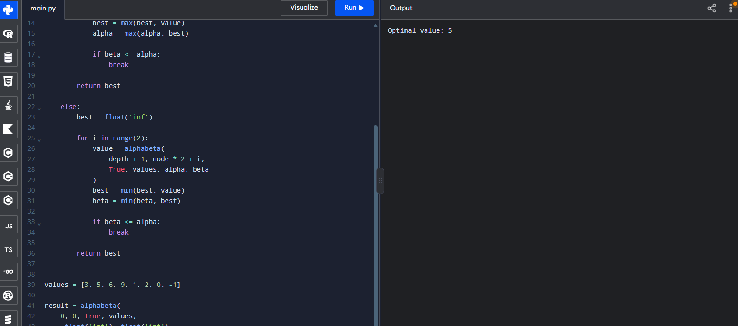Result: Thus, the Alpha-Beta Pruning algorithm was implemented successfully to find the optimal game value while reducing unnecessary node evaluations.

Experiment 15: Decision Tree
Aim: To write a Python program to implement a Decision Tree classification algorithm.
Algorithm:
- Import the required libraries.
- Load the Iris dataset.
- Divide the dataset into training and testing sets.
- Train a Decision Tree classifier.
- Predict the classes of test data.
- Display the predictions and accuracy.
Program:
def decision_tree(weather):
if weather == "Sunny":
return "Play Tennis"
elif weather == "Rainy":
return "Stay Indoors"
elif weather == "Cloudy":
return "Go for a Walk"
else:
return "Invalid Weather"

weather = input("Enter weather (Sunny/Rainy/Cloudy): ")
result = decision_tree(weather)
print("Decision:", result)

Sample Output:
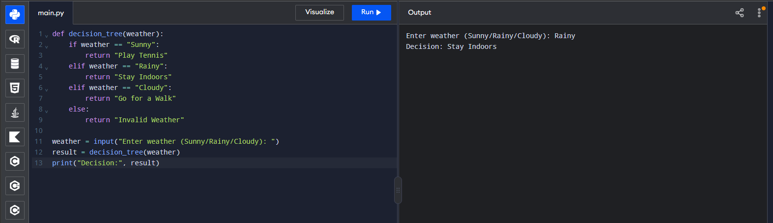Result: Thus, the Decision Tree classification algorithm was implemented successfully to classify Iris flowers. The sample output shows 100% accuracy on the test set.

